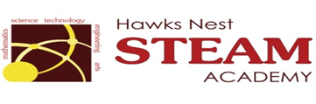School Counseling Program Newsletter
Shandrai Silva, School Counselor | January 2017

Counselor Message  Happy New Year! As we enter the second half of our school year, we are geared up for even more wonderful opportunities at Hawks Nest!  In December, the school counseling program continued with classroom guidance lessons, small group counseling and individual meetings with students. In classroom guidance, we continued with digital citizenship lessons and lessons on kindness and giving. On December 6th, we recognized GCS Kindness Day by wearing pink.  Check out the Look What’s  Happening information and stayed  tuned for more!  _________________________  How to see the school counselor  Classroom guidance classes are weekly based on grade level specials schedule. Small group counseling and individual counseling by self -referral, parent referral, teacher referral, administrator referral or counselor initiated.  Contact School Counselor at 704-866-8467or sosilva@gaston.k12.nc.us. | Home of the Hawks    The NED Show - Jan. 6th  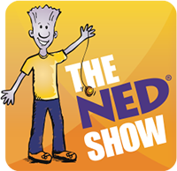  Never Give Up, Encourage Others and Do Your Best!  No Name-Calling Week  January 16th – 20th  Kindness in Action!  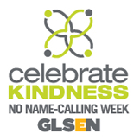  GCS Kindness Challenge Week  January 25th – January 27th  *Wear yellow on Jan. 25th | Character Education  “We’re Soaring with Good Character”  ______________________________  The character trait of the month is Perseverance.  Perseverance means a steady will to complete a task in spite of any obstacles before you. Students will have an opportunity to learn more about perseverance through morning announcements and classroom activities.  _____________________________________  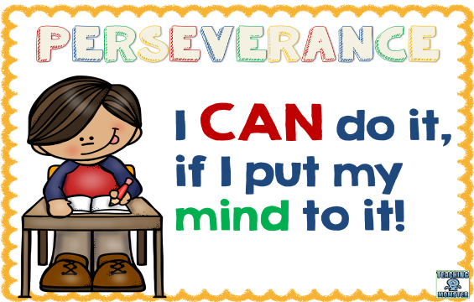  “Intelligence plus character- that is the goal of true education.”  Dr. Martin L. King, Jr.  January is  National Mentoring Month  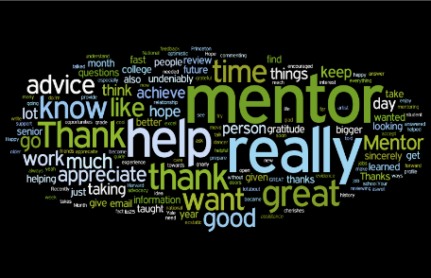  Thank You Mentors!

